MongoDB Assignment C
- Find students with marks greater than 80.
db.Students.find({marks:{$gt:80}})

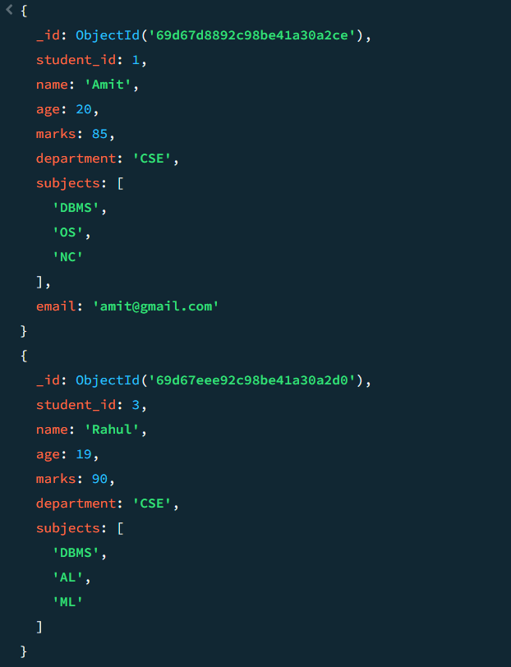

- Find students aged less than or equal to 20.
db. Students.find({age:{$lte:20}})

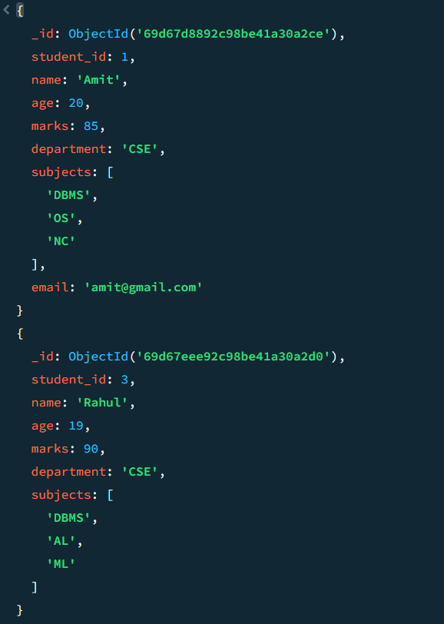

- Find students with marks between 70 and 85.
db. Students.find({marks: {$gte:70, $lte:85}})

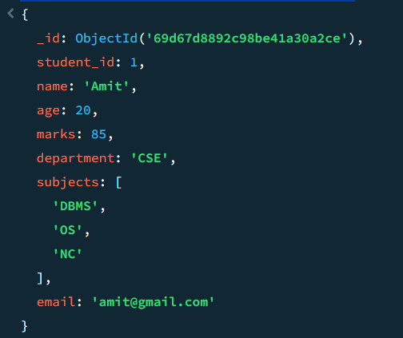

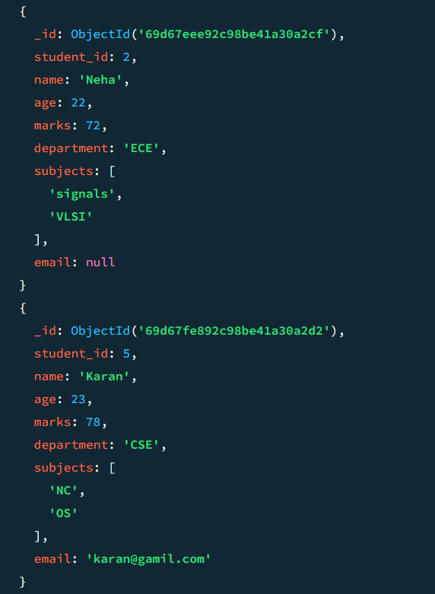

- Find students not belonging to CSE department.
db. Students.find({department:{$ne:"CSE"}})

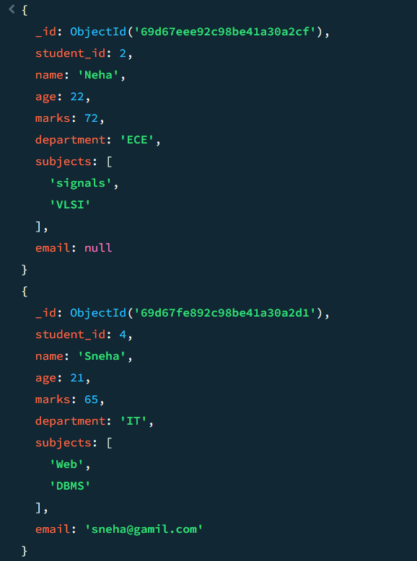

- Find students whose age is exactly 21.
db. Students.find({age:21})

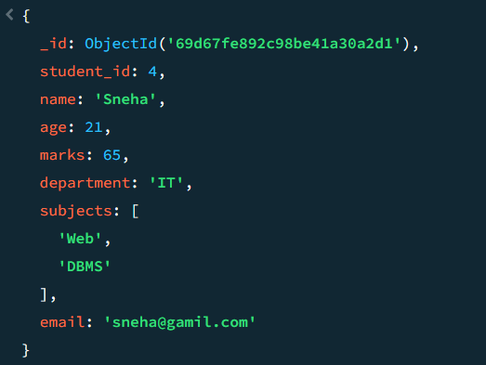

- Find students with marks less than 75.
db. Students.find({marks: {$lt:75}})

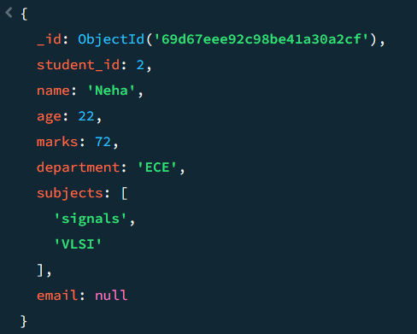

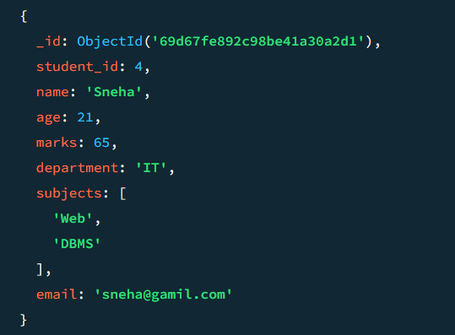

- Find students whose department is either CSE or IT.
db. Students.find({department: {$in: ["CSE","IT"]}})

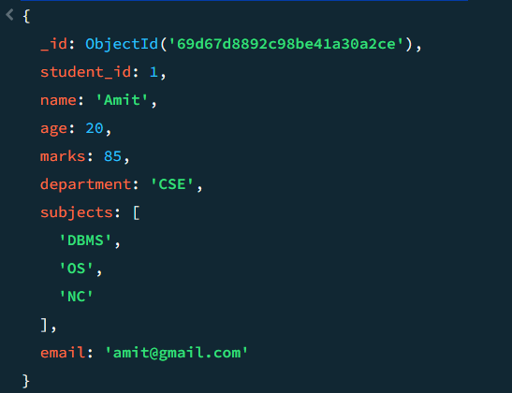

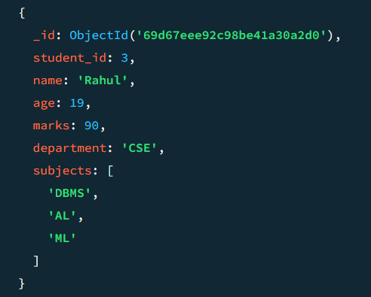

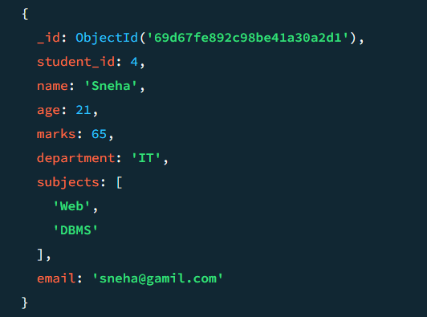
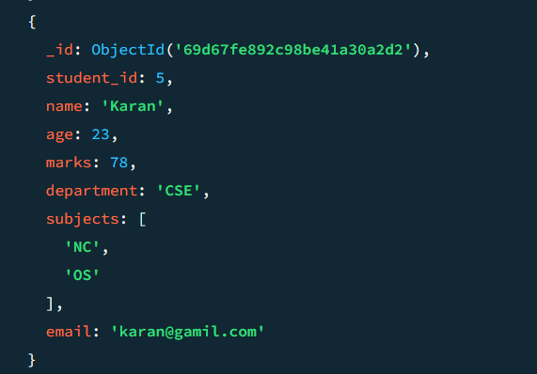

- Find CSE students with marks above 80.
db. Students.find({department:"CSE”, marks:{$gt:80}})

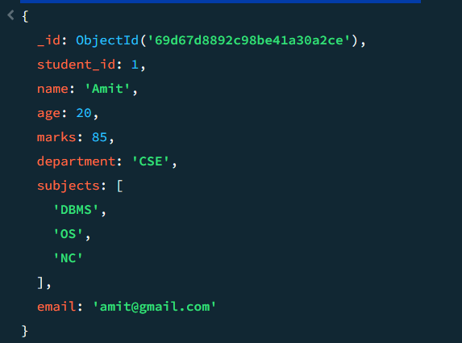

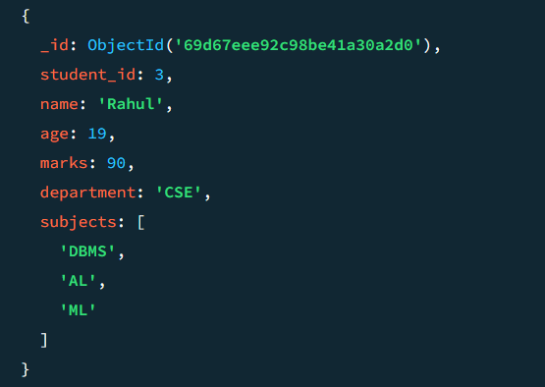

- Find students who are in CSE or have marks above 85.

db. Students. Find({department: {$in:[“CSE”,”IT]}})

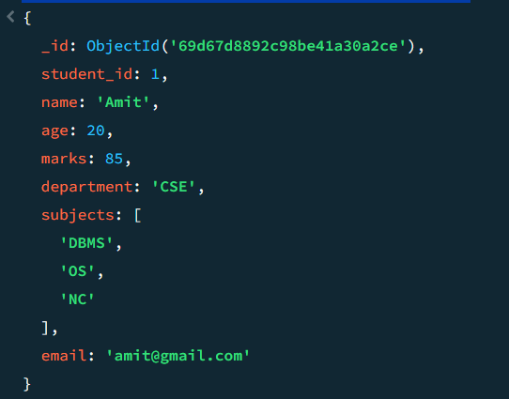

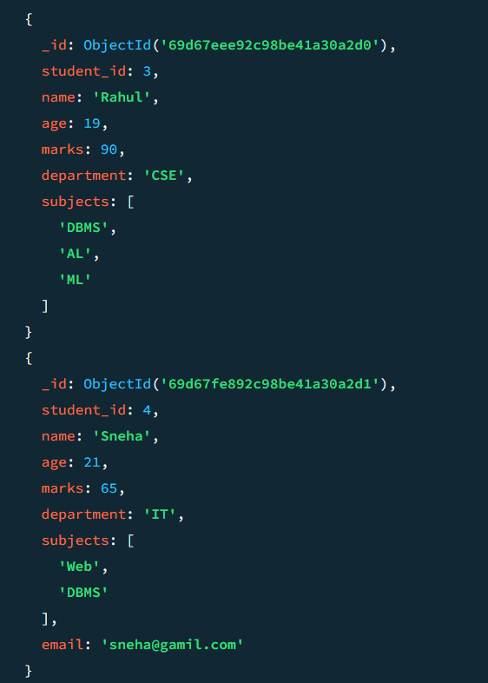

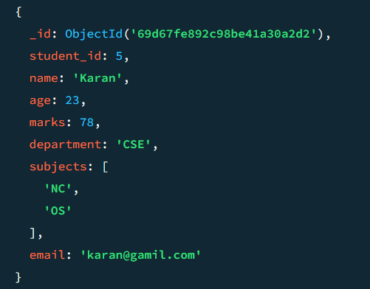

- Find students who are NOT in IT department.

db. Students. Find({department:{$ne: “IT"}})

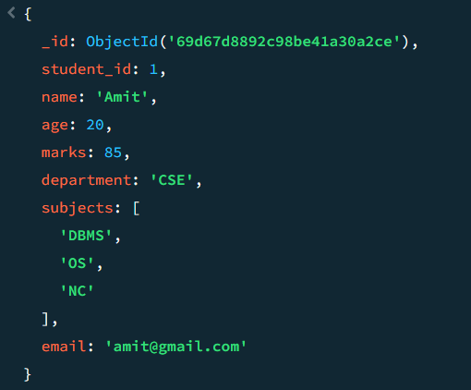

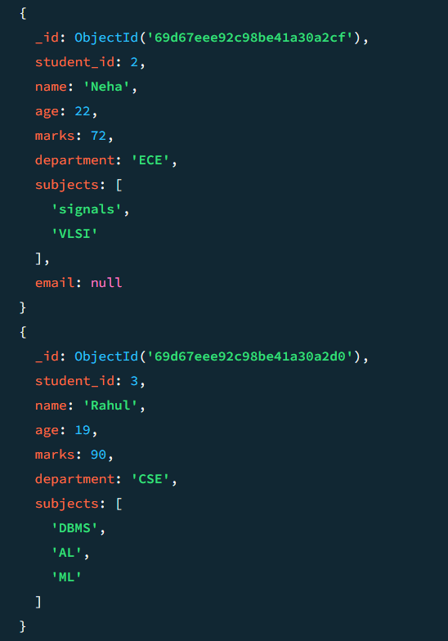

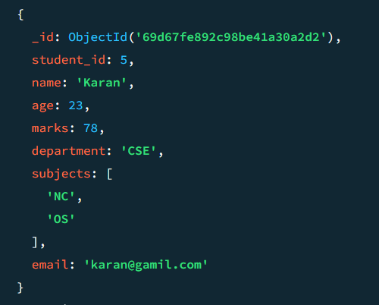

- Find students with marks not between 70 and 85.

db.Students.find({marks:{$not:{$gte:70,$lte:85}}})

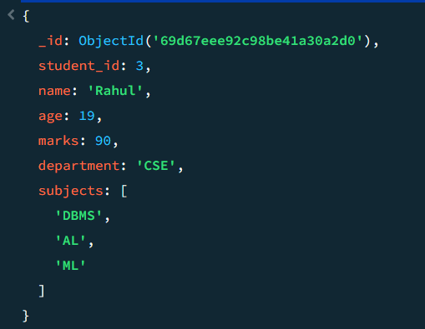

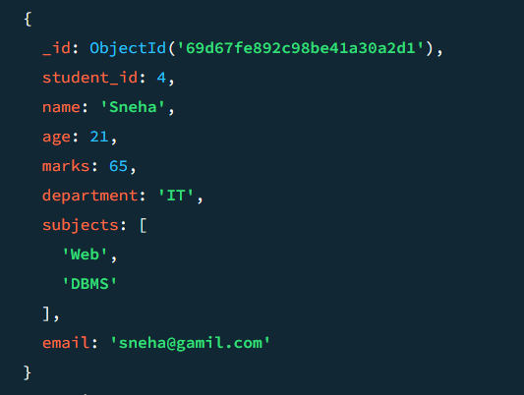

- Find students aged above 20 and not in ECE.

db.Students.find({age:{$gt:20},department:{$ne:"ECE"}})

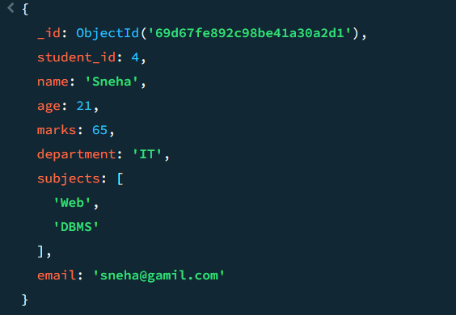

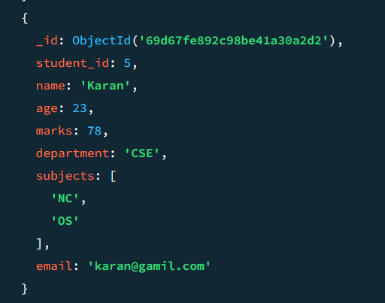

- Find students who are either IT students or have marks less than 70.

db.Students.find({$or:[{department:"IT"},{marks:{$lt:70}}]})

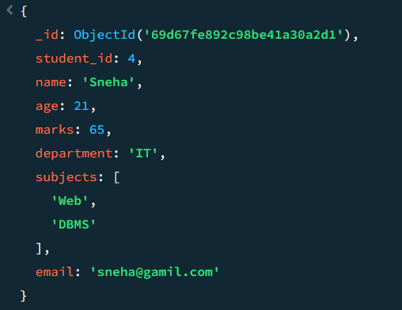

- Find students who are not CSE and not IT.

db. students. Find ({department: {$nin: ["IT","CSE"]}})

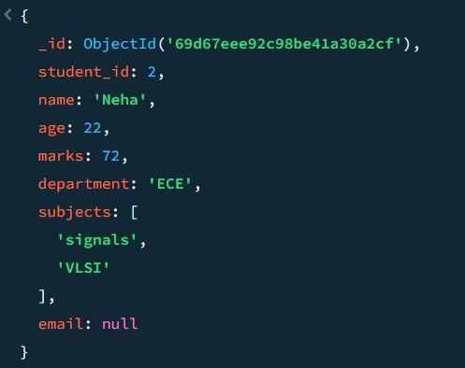

- Find students who have an email field.

db.students.find({email:{$exists: true}})

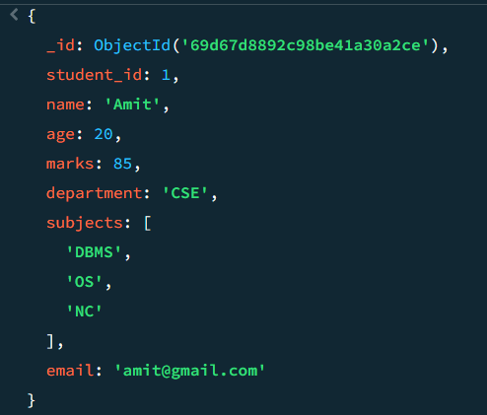

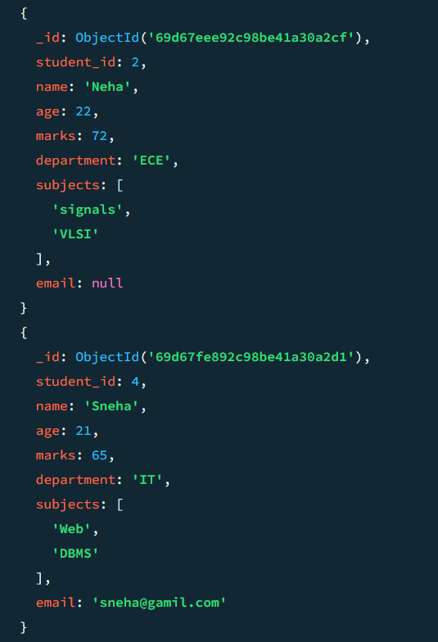
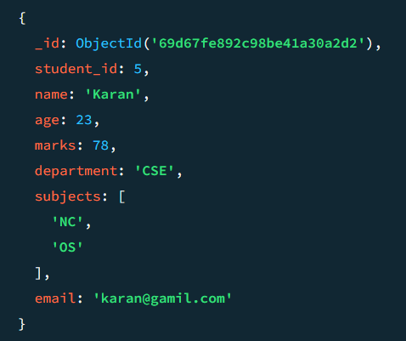

- Find students who do not have an email field.

db. Students. Find({email:{$exists: false}})

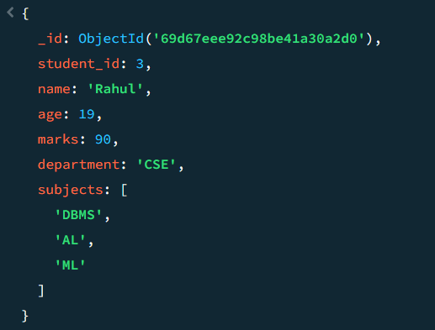

- Find students whose email value is null.

db.Students.find({email:{$type:"null"}})

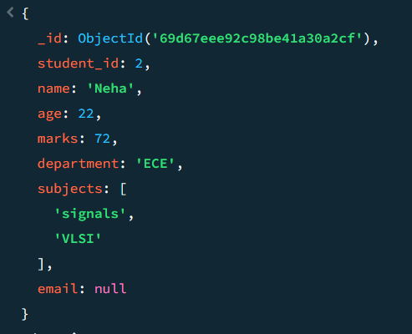

- Find students whose marks field is of type integer.

db.Students.find({marks:{$type:"int"}})
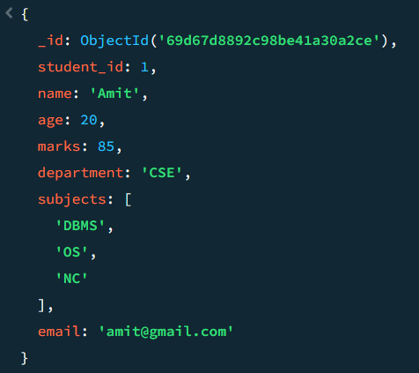

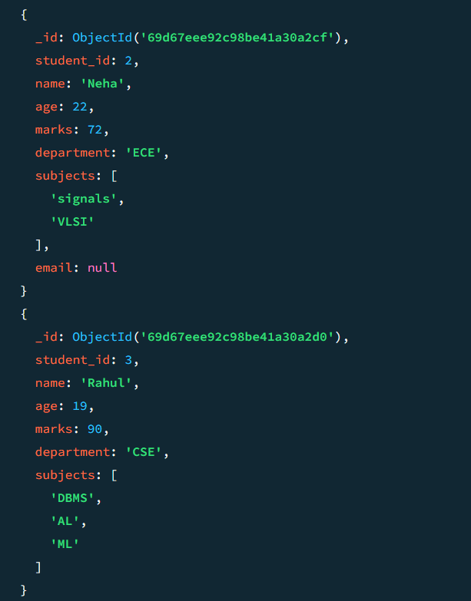

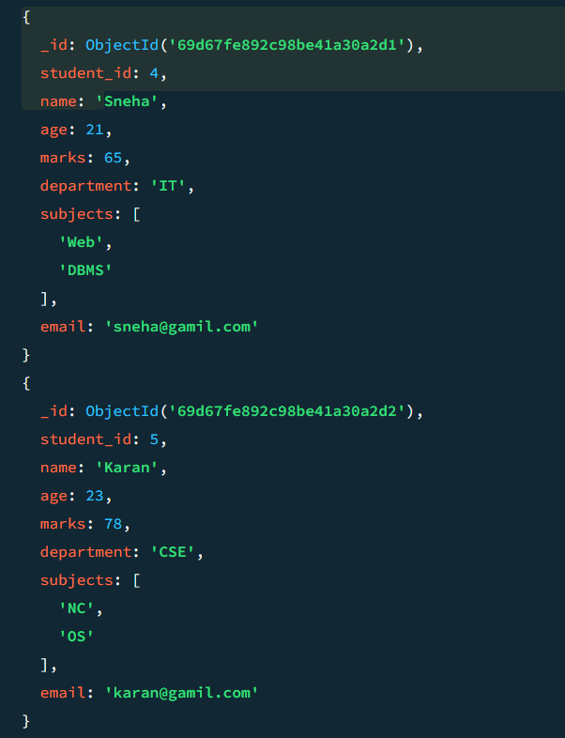

- Find students who have subjects’ field.

db.Students.find({subjects:{$exists:true}})

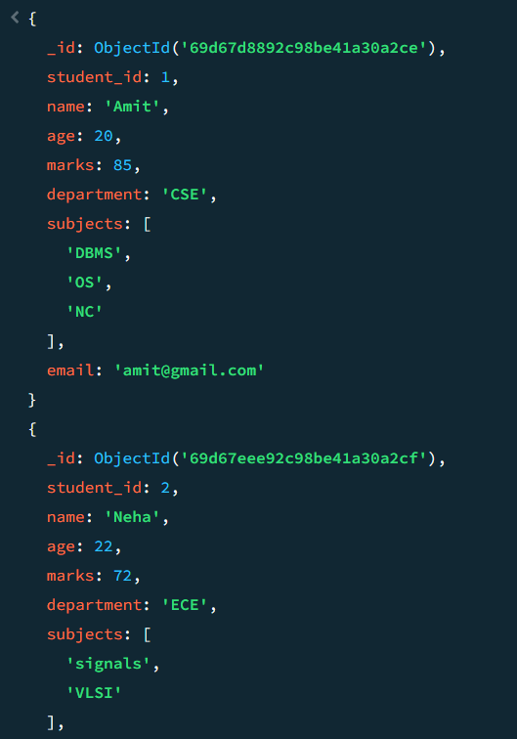

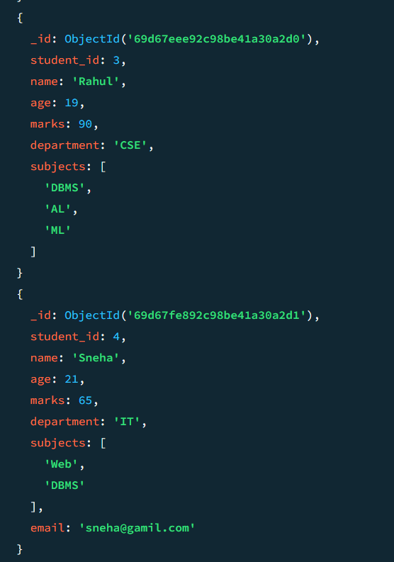

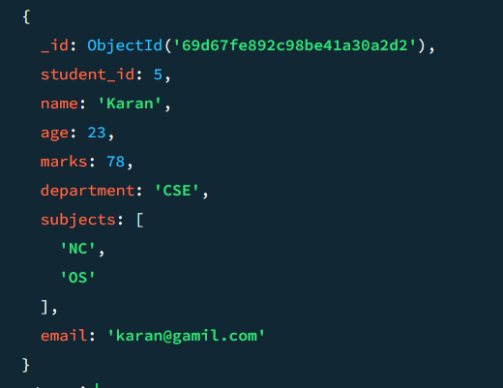

- Find students whose age field is missing.

db.Students.find({age:{$exists:false}})

ANS. There is no students whose age field is missing.

- Find Students where marks modulo 5 equals 0.

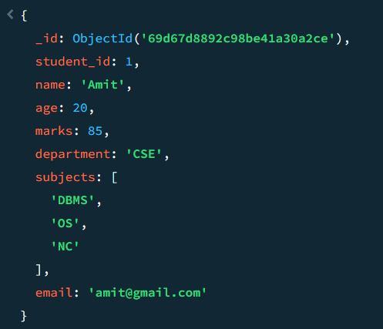

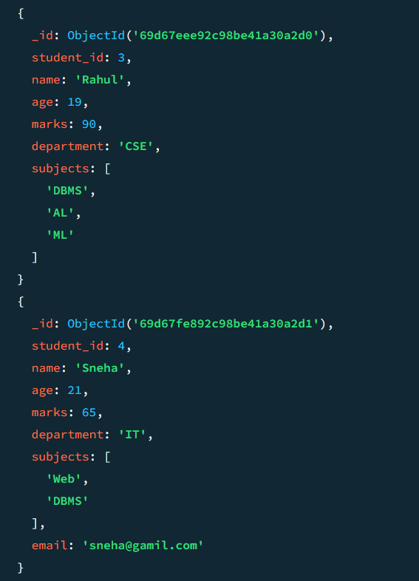

- Find students whose name starts with letter “A”.

db.Students.find({name:{$regex:"^A"}})

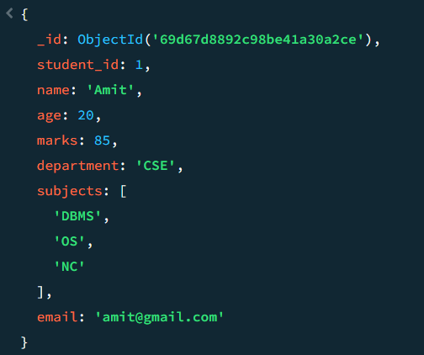

- Find students whose email ends with gmail.com.

db.Students.find({email:{$regex:"gmail.com$"}})

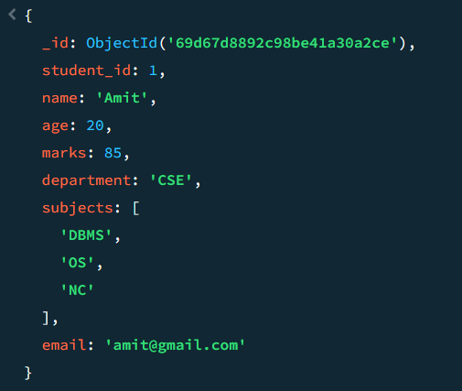

- Find students who have more than 2 subjects.

db.Students.find({"subjects.2":{$exists:true}})

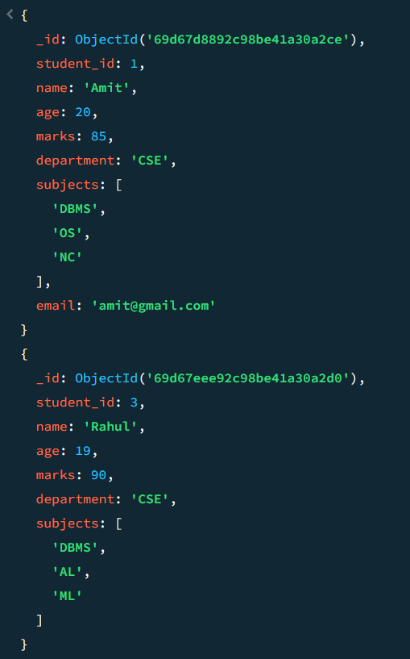

- Find students whose marks are greater than their age × 3.

db.Students.find({$expr:{$gt:["$marks",{$multiply:["$age",3]}]}})

